PHP (Hypertext Preprocessor)

Html 5.0 (HyperText Markup Language)

CSS 3 (Cascading Style Sheets)

JQuery (JavaScript library’s)

JQuery are a set of JavaScript libraries that has been implemented and used to make writing JavaScript easier, as they are exactly the same, and has been designed to simplify html. For this project we used version 3.1.0 from google library [1] [2]. We have used JQuery everywhere on the website, as it handles many things, these being:

Navigation

JQuery was used on the navigation rather than using the normal <a href=””> this was used because of how the site works. Instead of going to a new page the page that we want to the user to go to is loaded into an element that is on the page, this means that effectively the entire website is on the same page, of course this has its own benefits, as this allows us to hide pass variables from the Address bar on the page, if the user cannot modify the address they can’t access something they should not be accessing, for example if we choose to hide catalogue items from certain users then they cannot modify the address bar to find items that they are not supposed to, of course this can also be done using PHP, but if the user does not have to option to do it then it stops them from even attempting to do that. [image 1] of course the user can still see the id of the item when looking in the developer tools when looking at the networking traffic [image 2] of course if the user is able to access a page for an item they are not supposed to book, they won’t be able to do it anyway because when booking the item it also checks the users Information before they are able to book it.

Loading Pages

Much like the navigation we load every page onto one page, this allows the page to feel like it is loading much faster. This works together with the navigation in order to display the pages and for pretty much the same reasons, this works by finding the element that the user has cocked on, and then loading into another element a page they corresponds to the element clicked. Below is an example of how the code works.

$(document).ready(function() {

$(".addi").click(function() {

$(".holder").show();

$(".holder").load("ajax/Pages/Inventory/add_inventoryImage.php");

}); });

Calling Ajax

We also use JQuery for calling AJAX and JQuery’s version of Ajax is much easier to use, it allowed us to gather the information from textboxes and selection boxes on the page and then set them in variables to be sent off to other pages, this allowed information to be transferred to other pages without having to be redirected.

Disabling/hiding and displaying elements

Of course using this allows the app to disable buttons and other items that are not needed or should not be used by the user at a certain time, there are a few examples of this, and one being on the administrative pages, and on these pages the website disables the textboxes and hides buttons that are not being used. When the edit button is pressed by the user it will enable the textboxes that are relevant to the one that is pressed, it will also display the save and cancel buttons as they would only be needed once they original edit button has been pressed, this is used as the website does not need to show elements and objects to the user that they don’t currently needed to edit.

Changing and creating ID’s and classes on HTML elements

This also works in conjunction with hiding and displaying elements. This allows the website to know what element needs what attributes, as if each element had the same attribute it can cause problems scenically when using ID’s as an ID can only be used once on the page. The website has been made to set the ID Attribute to an element only when it needs it, this allows the website to only collect the correct information.

AJAX (asynchronous JavaScript and XML)

Ajax used on the site as this allowed the pages to move data from one page to another, used all over the website this was extremely helpful, especially on the page where we had to check if the user can book the item, when they selected two dates from the select boxes it would send them to the script that would check if the dates that the user imputed where available for them to book, if we done this with normal PHP they would then be redirected to another page or just have an error when they tried to book an item that has already been booked for them days, but as we could send this information and get a result back it made it easier for the user to navigate and see if they could book things or not.

Ajax is a good way to cut loading times, the site only needs to load particular data when it's needed, using ajax means that we don't use large

MySql (databases)

# Bibliography

|  |  |
| --- | --- |
| [1] | "Google Hosted Libraries," Google, 17 January 2017. [Online]. Available: https://developers.google.com/speed/libraries/. [Accessed 2016]. |
| [2] | "Jquery," Jquery, [Online]. Available: https://jquery.com/. |

Appendix

Image #1

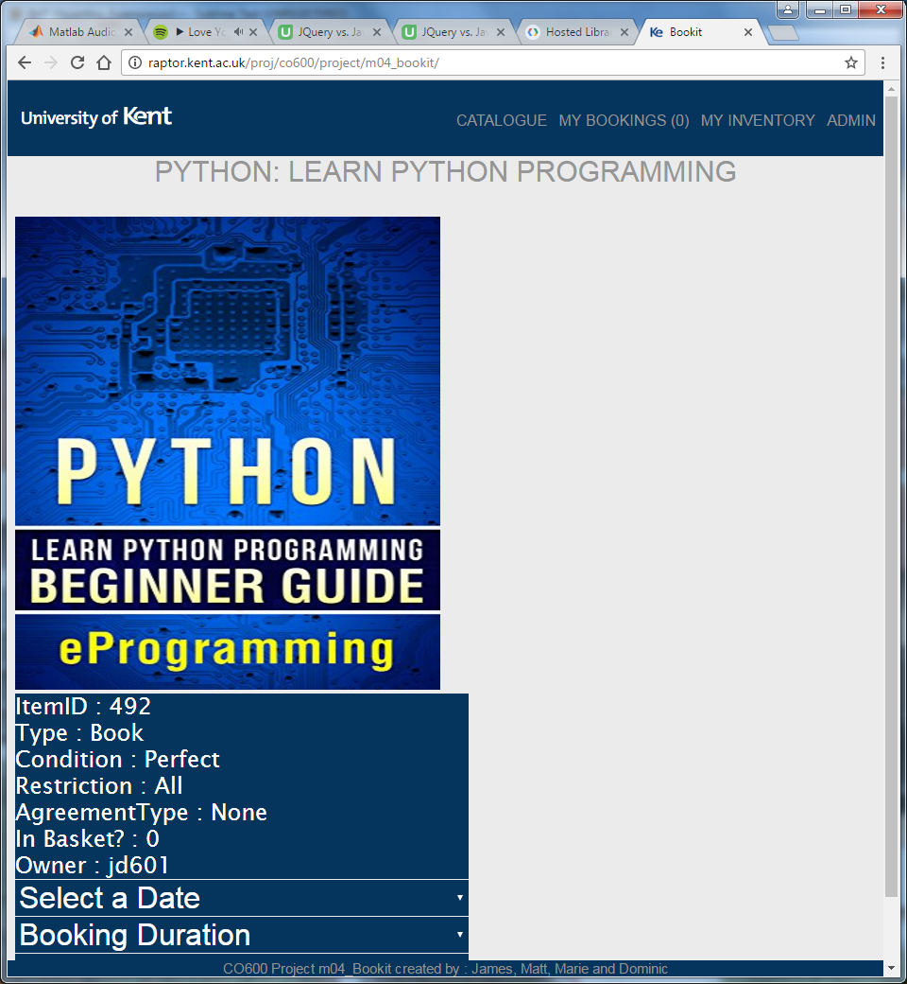

Image 2

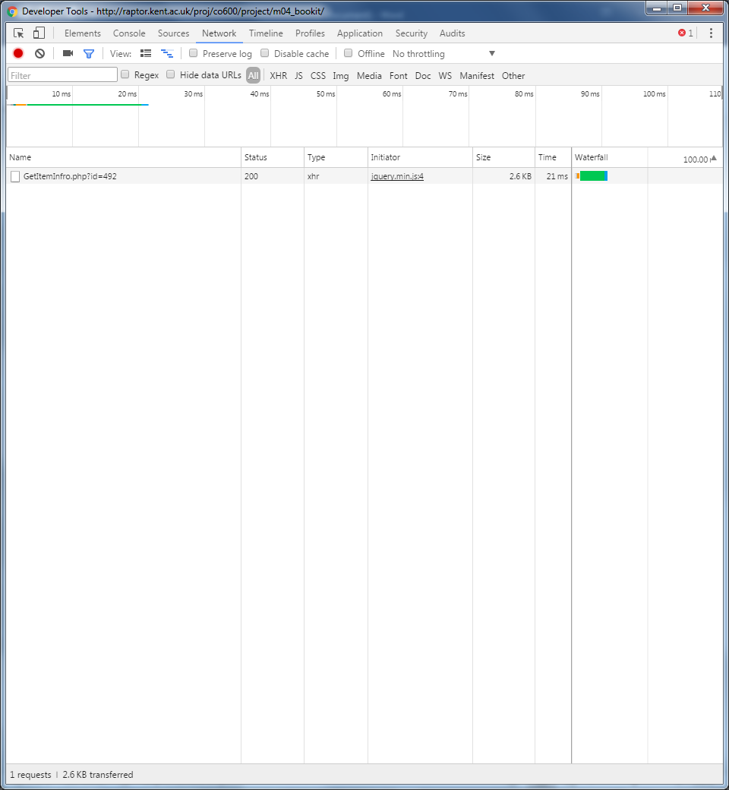

Image 3

